Microcontroller Training Lesson 02 – Getting Started
By Bryan A. CrazyUncleBurton Thompson
Last Updated 3/8/2026

Overview
This lesson will show you how to compile and upload a basic “Hello World” program to a microcontroller.

Theory
This is our first program and we’re learning a lot of things all at once. We will start by compiling and uploading an existing program. We make the circuit as easy as possible by using a pre-built module which only connects one way to the microcontroller.

Hardware Required
1 – M5Stack Tab5 Microcontroller Development Board
1 – M5Stack Dual LED Module
1 – 4 wire cable with female M5Stack / Grove / JST-PH connectors on both ends
1 – USB cable to connect the USB-C port on the development board to your computer

Objectives
- Familiarity with the Tab5 development board
- Familiarity with the VS Code Integrated Development Environment
- Familiarity with the circuit
- Compile our first program
- Upload the program to the development board
- Test the program

The M5Stack Tab5 Microcontroller Development Board

The M5Stack Tab5 microcontroller development board has an ESP32-P4 microcontroller with three cores. It has an ESP32-C6 Communications IC with support for 2.4 GHz Wi-Fi 6, Bluetooth 5 (LE), Zigbee 3.0, and Thread 1.3. It has a 5” LCD touchscreen, camera, microSD slot, Audio Inputs and Outputs, Microphones, a Real Time Clock, a 6-axis accelerometer/gyro sensor, and many ways to connect to external circuits!
The manufacturer’s datasheet for the Tab5 is located here. You can find information like schematics, external hardware connections and more: https://docs.m5stack.com/en/core/Tab5
M5Stack provides a super-rich development ecosystem, including sensors, modules and accessories: https://shop.m5stack.com/collections/unit

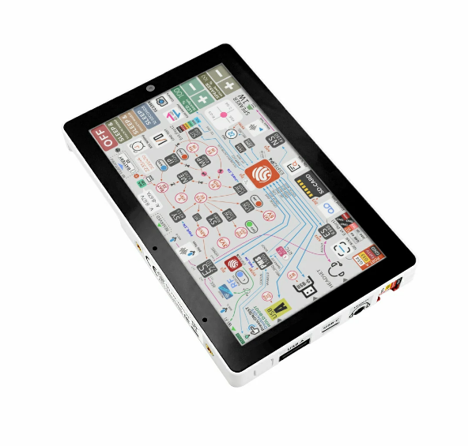
Figure 1 – The M5Stack Tab5 Development Board

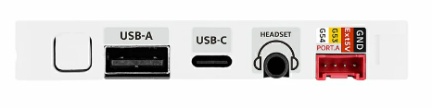
Figure 2 – Tab5 Bottom Side

- We can supply power to the Tab5 through its USB-C port. Connect the Tab5 USB-C port to your computer with a USB cable.
- The white “U” shaped button on the left is the On/Reset/Off button.
- Press the button once to turn on the screen. You should see the factory firmware running on the controller. It shows some useful data about the hardware and some live data on the LCD:

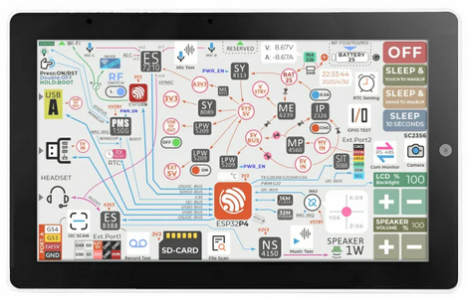
Figure 3 – Tab5 Running Factory Firmware

- Press and release the power button once. Note that the unit powers off and back on (we call this a reset).
- Double press and release the power button to turn the controller off.
- Look at the red PORT.A connector on the bottom of the controller. This connector supplies 5V Power (Red) and Ground (Black) to an external circuit and exposes two General Purpose Input/Output pins which connect directly to the microcontroller pins G53 (Yellow) and G54 (White). M5Stack uses these connectors to the sensors they supply. The sensors they sell even come with the cable to connect them to the Tab5!

The M5Stack Dual LED Module
Note: This isn’t a product for sale at M5Stack. We bought a module with a prototype board and connected two LEDs – each controlled by one of the GPIO pins. The circuit looks like this:

